RE: Memorial Tribute Book

As much of an impact and inspiration the Honorable Senator Monthian Buntan had in his homeland, he was an equally towering figure of strength and wisdom within the Asia and Pacific region through his leadership facilitating cooperation between various disability advocacy groups and with international institutions such as the UN Economic Social Commission for Asia and the Pacific.

From the foundation of the Asian and Pacific Disability Forum in 2003, Senator Buntan was involved in shaping and supporting a collective regional vision of disability rights and welfare that sought to amplify local concerns into global significance. He always brought boundless enthusiasm and unique insights benefitting all who had the pleasure to meet and work with him.

Something he would say was, “to give up on giving up.” This testament to his perseverance and optimism for the future reflects his belief that nothing is impossible if we never stop trying to “make the right real” and manifest the world we want rather than just accepting the world we have. Senator Monthian Buntan will be missed beyond measure and we must all rise to fill the void left with his untimely passing.

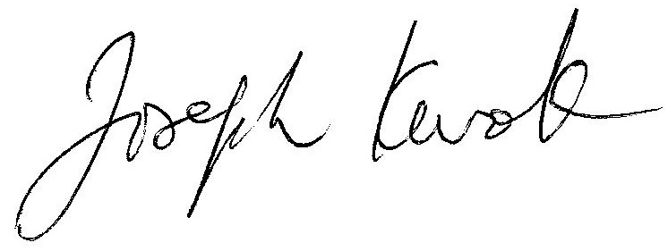

Joseph Kwok, PhD, BBS, JP

Chair of APDF

Mr. Sung-min Jo,

Secretary General of APDF